#include &lt;LiquidCrystal.h&gt;
LiquidCrystal lcd(12, 11, 5, 4, 3, 2);
void setup() {
lcd.begin(16, 2);
}
void loop() {
lcd.setCursor(0, 0);
lcd.print(&quot;16x2 LCD MODULE&quot;);
lcd.setCursor(2, 1);
lcd.print(&quot;hello,world!&quot;);
}

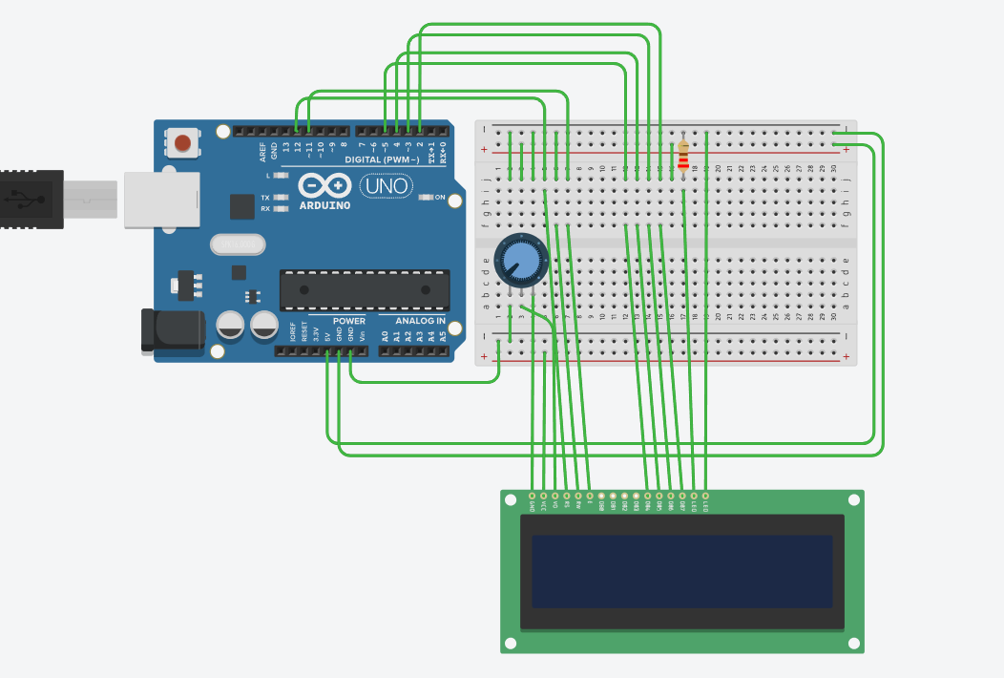

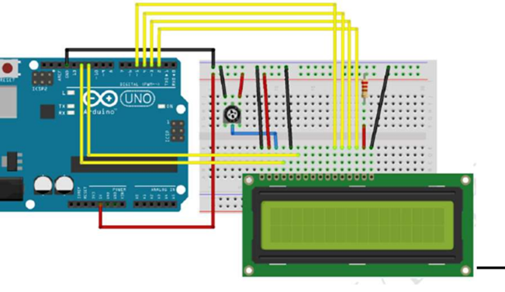

LCD
Pin Name Connect To
1 VSS GND
2 VDD 5V
3 V0 Middle pin of
potentiometer
4 RS Pin 12
5 RW GND
6 E Pin 11

11 D4 Pin 5
12 D5 Pin 4
13 D6 Pin 3
14 D7 Pin 2
15 A
(LED+) 5V (via 220Ω resistor)
16 K (LED-
) GND
Pot
Pin Connect To
Left GND
Right 5V
Middle LCD Pin 3
(V0)

